Ideation Phase
Brainstorm & Idea Prioritization Template
Date | 15 August 2026
Project Name | Automated Network Request Management in ServiceNow
Maximum Marks | 4 Marks

Brainstorm & Idea Prioritization Template:
Brainstorming provides a free and open environment that encourages everyone during the ideation process to participate in the creative thinking process that leads to problem solving. For the Automated Network Request Management project, the project work explores multiple ways to reduce manual effort, improve request routing, automate approvals and assignments, and provide faster fulfillment of network-related service requests. Ideas are generated first and then grouped and prioritized based on their importance and feasibility.
Project Problem Statement: Network-related service requests are often handled through manual communication, manual routing, repeated approvals, and task assignment. This can cause delays, missed SLAs, inconsistent processing, and unnecessary effort. The project aims to automate the request lifecycle using ServiceNow Service Catalog, workflows/flows, approvals, task assignment, notifications, and, where possible, network automation integration.
Step-1: Problem Identification and Problem Statement Selection
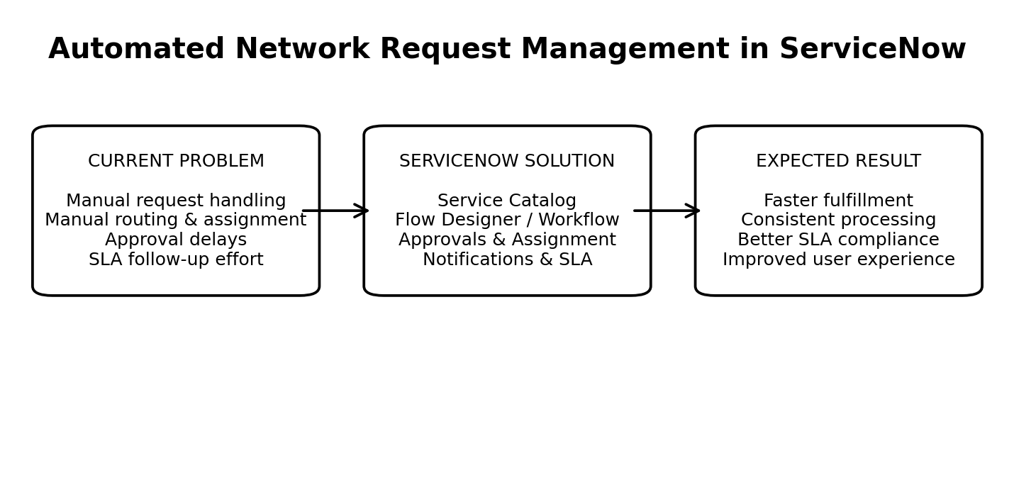
Activity | Discussion / Outcome | Selected Direction
Project Problem Review | Review common issues in network request handling. | Focus on manual processing delays.
Problem Identification | Requests require manual routing, approvals, assignment and follow-up. | Automate the request lifecycle.
Problem Statement | Users need a simple way to submit network requests and track progress. | Use ServiceNow Service Catalog and automated flows.
Goal | Improve speed, consistency, SLA compliance and user experience. | Build an end-to-end automated request process.

Step-2: Brainstorm, Idea Listing and Grouping
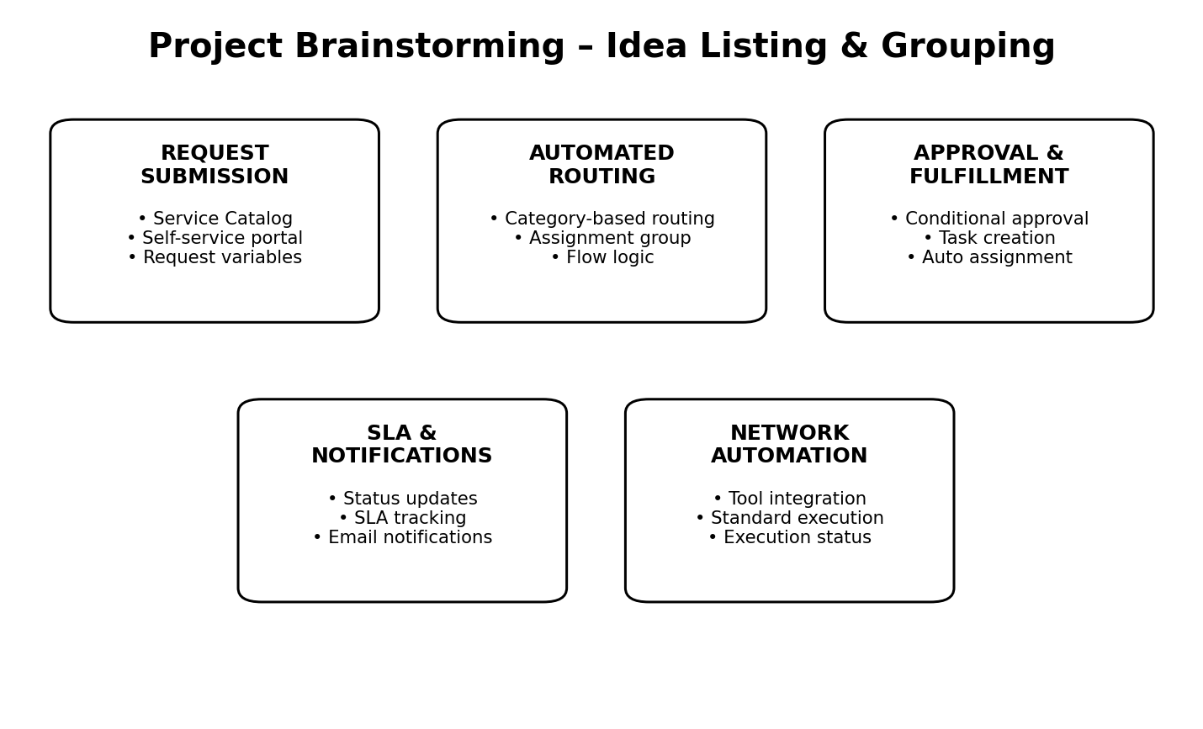
The project work brainstormed possible solutions without initially judging the ideas. The ideas were then grouped into functional areas that support the Automated Network Request Management solution.
Request Submission
- Create a ServiceNow Service Catalog item for network requests.
- Use structured variables for request type, source/destination, priority and business justification.
- Provide a self-service portal for easy submission.
Automated Routing
- Route requests automatically to the correct network support group.
- Use request category and selected service to determine assignment.
- Reduce manual triage by using Flow Designer logic.
Approvals
- Trigger approvals based on request type and risk.
- Send approval tasks to the appropriate approver.
- Continue fulfillment automatically after approval.
Task Assignment
- Automatically create fulfillment tasks for network project works.
- Assign tasks based on group and request conditions.
- Track task status from the RITM/request record.
Notifications & SLA
- Notify users when requests are submitted, approved, rejected or completed.
- Use SLA tracking to identify approaching deadlines.
- Improve transparency through status updates.
Network Automation / Integration
- Integrate with network automation tools where feasible.
- Execute approved standard changes automatically.
- Return execution status to ServiceNow.
Idea Grouping Summary
Group | Main Purpose | Expected Benefit
Catalog & Portal | Easy request submission | Better user experience
Routing & Assignment | Automated work distribution | Less manual triage
Approvals | Controlled authorization | Improved governance
Tasks & SLA | Track fulfillment | Faster and consistent processing
Notifications | Keep users informed | Better transparency
Integration | Automated execution | Reduced human intervention

Step-3: Idea Prioritization
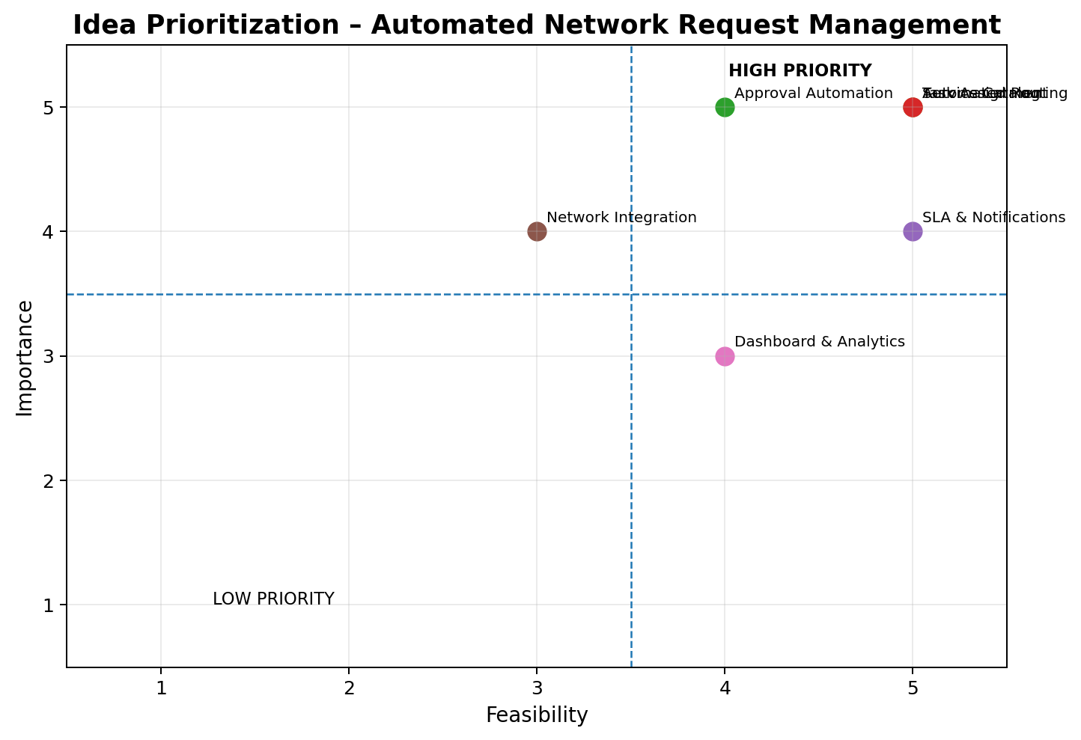
Ideas are prioritized by considering two factors: Importance to the project and Feasibility of implementation. High-importance and high-feasibility ideas are selected first for the core solution.
Idea | Importance (1–5) | Feasibility (1–5) | Priority | Reason
Service Catalog Request | 5 | 5 | High | Core entry point for standardized network requests.
Automated Routing | 5 | 5 | High | Directly reduces manual triage and delays.
Approval Automation | 5 | 4 | High | Provides control while reducing approval effort.
Automatic Task Assignment | 5 | 5 | High | Ensures work reaches the correct network project work.
Notifications & SLA Tracking | 4 | 5 | High | Improves transparency and SLA compliance.
Network Tool Integration | 4 | 3 | Medium | Strong future value but depends on available integration.
Dashboard / Analytics | 3 | 4 | Medium | Useful for monitoring and reporting after core automation.
Final Prioritized Solution
- 1. Service Catalog + Self-Service Portal
- 2. Automated Routing and Group Assignment
- 3. Conditional Approval Workflow
- 4. Automatic Fulfillment Task Creation and Assignment
- 5. Notifications and SLA Tracking
- 6. Optional Network Automation Tool Integration
Expected Outcome: A streamlined ServiceNow solution that allows users to submit network requests through self-service, automatically routes and approves requests, creates fulfillment tasks, keeps users informed, tracks SLAs, and supports automated execution where integration is available.
Project: Automated Network Request Management in ServiceNow

